2018 Data Professional Job Market

By George Oddoye , Vidhyanandhi Jegannathan

Data Profession is becoming the “coolest” profession of the 21st century. There is overwhelming amount of information available in the academic arena and the job market to render us helpless, not knowing where to begin our search and how to narrow down information to make meaningful conclusions.

The “Indeed Dataset “ created and maintained by Elroy on [www.kaggle.com](http://www.kaggle.com) , <https://www.kaggle.com/elroyggj/indeed-dataset-data-scientistanalystengineer> , is a fairly comprehensive dataset about the various aspects of data professional job market across the US . Data displayed was regarding job titles, job types, names of job offering companies, location of companies, type of industry for each company , salaries and necessary skills for job postings on [www.indeed.com](http://www.indeed.com) in 2018.

While researching for a meaningful topic for our project work , we were drawn to this dataset for the most compelling reason, none other than the fact that we were currently enrolled in a Data Analytics Bootcamp to equip ourselves with skills to step into the job market very soon and knowing the market trend would be priceless.

Studying the Indeed Dataset has led us to gather the following inferences:

**Top State across the nation that offer most number of Data Profession jobs**

California had the most number of Data professional jobs (1395 jobs ) and no other state came close to it in numbers . Trailing far behind was New York(601 jobs) , followed by Virginia(334 jobs), Texas(329 jobs), Massachusetts(271 jobs), Illinois(240 jobs) and Washington (222 jobs ).

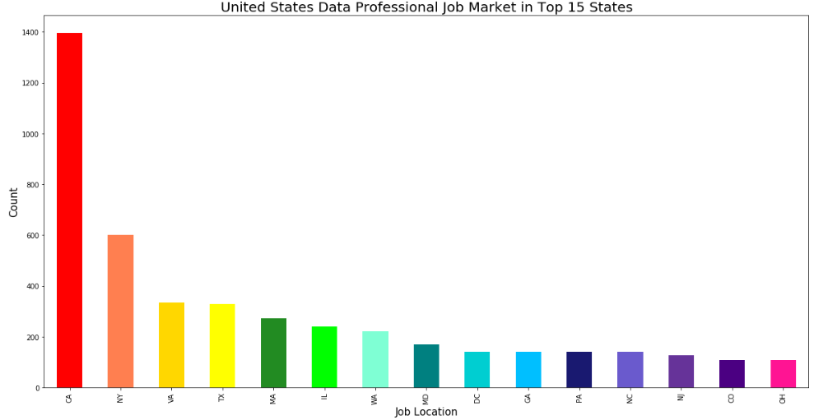

**The top 10 companies offering data profession jobs**

The top 10 companies offering data profession jobs are Booz Allen , Hamilton, Harnham, Capgemini, Facebook , KPMG LLP, Walmart ,Capital One, JPMorgan Chase, Google and IBM.

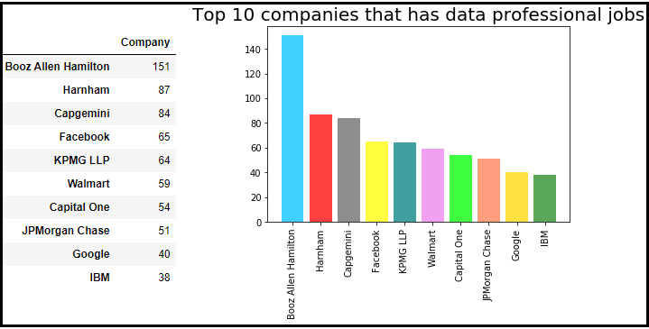

**Top Industries offering Data Profession jobs**

Fifteen Industries that are leading in the fielding of Data Analytics are Consulting and Business Services, Consulting and Business Services, Banks and Financial Services, Health Care, Insurance, Industrial Manufacturing, Retail, Education and Schools, Computers and Electronics, Consumer Goods and Services, Media, News and Publishing, Human Resources and Staffing, Telecommunications, Government, Pharmaceuticals.

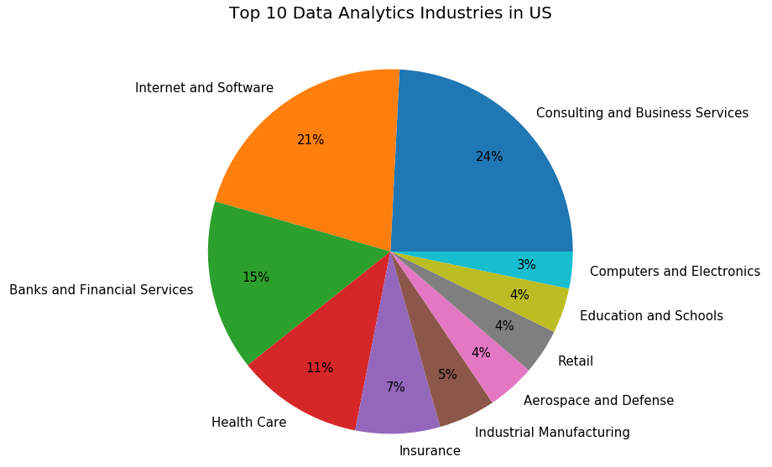

**Relation between Job types, Job Positions , Salaries :**

There were numerous job titles with varied verbiage for the listed job postings , however, they all were placed under three major categories of job types , namely , “Data Analyst” , “Data Engineer” and “Data Scientist”.

Typical to any job market , the data showed an increase in salary with rise in job position . Entry-level jobs received salaries from $30,000 to $99,999 , Mid-level jobs received salaries from $100,000 to $139,999 and Senior-level jobs received salaries from $140,000 and upwards. An interesting observation to be noted would be that almost all Data Analyst jobs were Entry-level jobs and almost all Data Scientist jobs were Senior -level jobs.

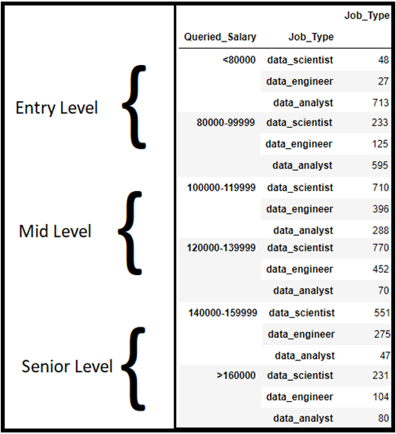

**Skills required for each of the 3 Job Types and 3 Job Levels**

Of the plethora of skills that one can acquire today , the few that are essential to a professional seeking a Data Analytics job are Python, SAS, R, Machine Learning, SQL,Tableau, Hadoop , Java and Spark .

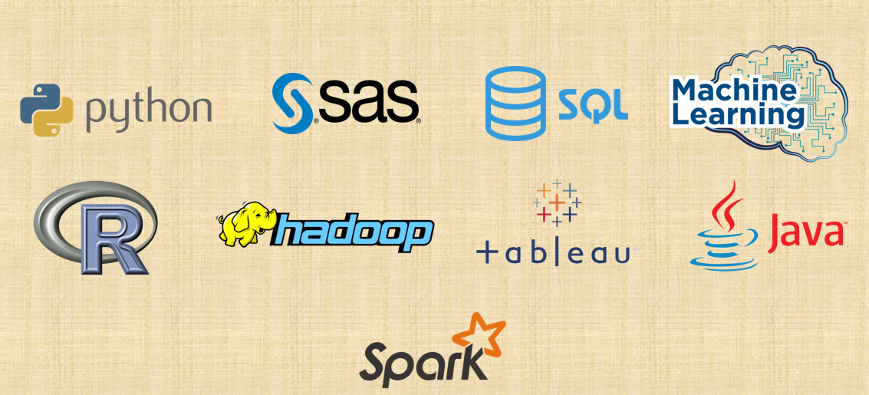

**The Bar graphs below showcase the distribution of skills among the different job types and job positions.**

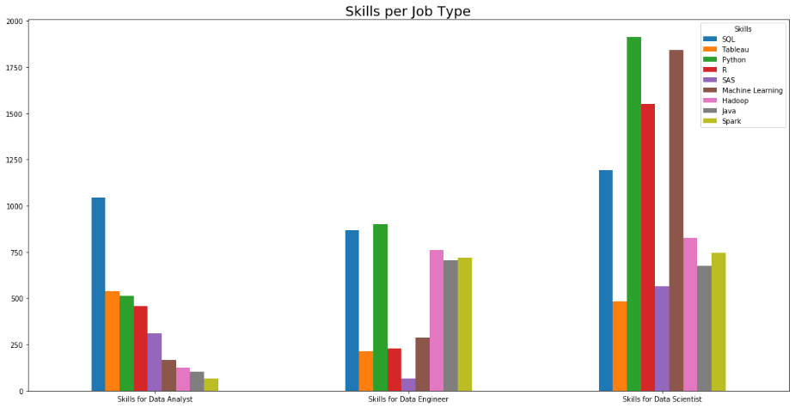

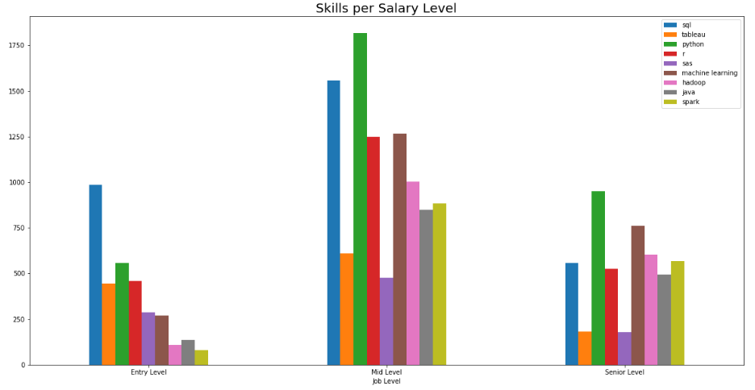

**What are the top 4 skills a hopeful data professional should focus on mastering in order to be an ideal candidate for an entry, mid, or senior level position in the fields of Data Science, Data Engineering, or Data Analysis?**

SQL seems to be the Top Skill for an individual applying for an Entry level position or a Data Analyst’s job. All 4 skills needed (SQL, Python, R and Tableau ) for these two categories are the same with almost the same level of importance .

As data professionals transition into a Mid level job their competency of Python and Machine Learning become more prevalent. By the time they reach Senior levels they should’ve fully mastered python and machine learning as well as have a thorough understanding of Hadoop and Spark .

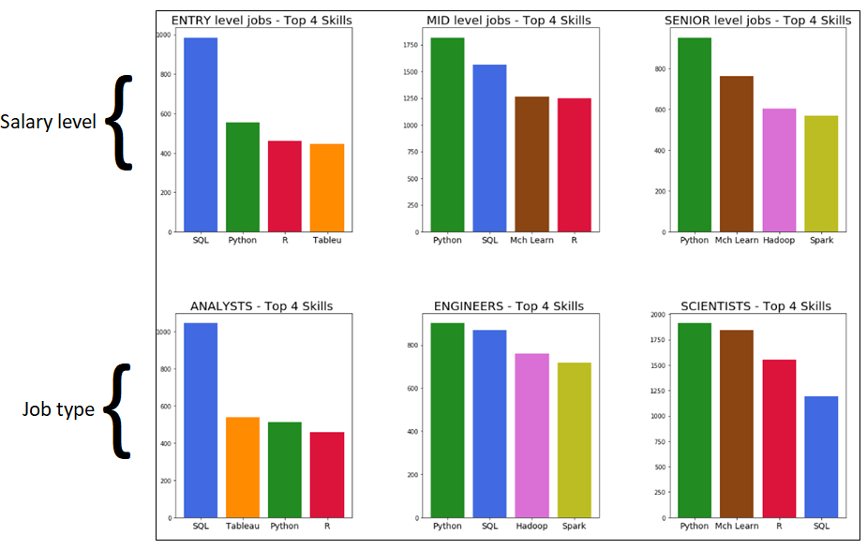

**In conclusion:**

A data professional looking to break into this job market should focus mostly on mastering Python and SQL. As a data professional transition into a mid level job their competency of python becomes more prevalent as does machine learning. By the time a data professional reaches senior level they should’ve fully mastered python and machine learning as well as have a thorough understanding of Hadoop and spark .